May 1, 2026
{{ client_name }}
Palo Alto Networks Health Check

Opportunity Number: OP-{{ opportunity_number }}
Version Number: {{ revision_number }}

Table of Contents
Executive Summary 2
Objectives 2
Phases 2
Summary of Findings and Recommendations 2
Project Overview 3
Purpose 3
Scope 3
Objective 3
Approach/Methodology 3
{{ short_name }} Firewall Health Check 5
{{ short_name }} Environment Review and Analysis 5
Panorama 5
Review and Analysis of Panorama 5
PAN Firewall(s) 9
Review and Analysis of Firewall(s) 9
Recommendations 13
High-Level Recommendations 13
High-Level Firewall Recommendations 13
Appendix A: Reports 15
Appendix B: Interviews 16
Appendix C: References 17
Appendix D: Devices Included in Review 18
General 19
Copyright 19
Version Control 19

Executive Summary
{{ client_name }} ({{ short_name }}) engaged Optiv Security Inc. (Optiv) to perform a review of the organization’s existing Palo Alto Networks (PAN) environment. This report details the findings and makes recommendations for the current {{ short_name }} security design and implementation, a list of issues requiring remediation, a list of recommendations to address these issues, and a list of recommendations to better integrate and leverage the deployed technologies.

Objectives
The high-level objectives for this engagement were to:
- Review the current PAN Panorama(s) and identify any gaps.
- Review the current PAN firewall(s) and identify any gaps.

Phases
The phases of this engagement included:
- Planning
- Environmental Review and Planning
- Closing (Documentation and review of findings and recommendations)

Summary of Findings and Recommendations
# | Finding/Observation | Recommendation | Importance
 |  |  | High
 |  |  | Medium
 |  |  | Low

Optiv understands the importance {{ short_name }} places on IT security and sincerely appreciates the opportunity to have worked on this engagement. Please contact the Optiv project manager with any questions regarding these findings or the contents of this report.

Project Overview
The {{ short_name }} PAN Health Check project consists of:
- A comprehensive review of the deployed PAN firewall(s).
- A comprehensive review of the deployed Panorama(s).
Based on the findings, it presents a high-level design broken into a review of each device or High Availability (HA) cluster.

Purpose
The purpose of this document is to present the results of the PAN Health Check performed for {{ short_name }} on {{ report_date }}.

Scope
This document provides information specific to the {{ short_name }} PAN Health Check and includes details on the following:
- Firewall(s):
- Panorama(s):

Objective
After reviewing this document, {{ short_name }} security personnel should be able to:
- Identify the risks of the deployed PAN firewall(s).
- Identify the risks of the deployed PAN Panorama(s).
- Propose remediation steps for any identified issues.

Approach/Methodology
The approach used was based primarily on best practice guidelines and Optiv’s best practices.
- Conduct an initial internal and client kickoff call to determine the overall architecture and collect pertinent documentation.
- Perform a detailed walkthrough of the architecture together with the client key players based on the available documentation and in-house knowledge.
- Obtain access and inspect the configuration of key devices.
- Conduct on-site interviews with client key players to ensure the successful capture of all details and requirements.

The findings are documented and assigned a risk-level rating (see the table below), which describes the deviation from industry, vendor, and Optiv standards. It is meant to provide guidance and focus for remediation and improvement activities.
Table 1: Risk Ratings
Risk Level | Description
D-1 | Critical Deviation  Extreme deviation from industry, vendor, and Optiv standards, leading practices, or processes that pose extreme risk to the availability of the network and security infrastructure
D-2 | High Deviation  Major deviation from industry, vendor, and Optiv standards or processes poses a high risk to the availability of the network and security infrastructure
D-3 | Medium Deviation  Moderate deviation from industry, vendor, and Optiv standards or processes poses a medium risk to the availability of the network and security infrastructure
D-4 | Low Deviation  Slight deviation from industry, vendor, and Optiv standards and leading practices or processes poses a low risk to the availability of the network and security infrastructure
D-5 | No Deviation  Meets or exceeds industry, vendor, and Optiv standards and leading practices or processes pose no risk to the intellectual property of the network and security infrastructure

{{ short_name }} Firewall Health Check

{{ short_name }} Environment Review and Analysis
The main sites of the {{ short_name }} network is located in such and such locations.
Based on the review and discussions with the Network team, the review results are summarized in the table below.
These results pertain to the global network and security environment. A specific review of the currently installed firewall policies is presented in the next section.
Table 2: Process Observations
Review Current Architecture
Documentation | Network Documentation – talk about diagrams | D-5
Documentation | Device Configuration – talk about configuration | D-5
Policy | Policy, Standards, Guidelines  - Do they have a security policy or firewall standards?  - Do they adhere to them? | D-4
Process | Firewall Change Control  - Do they have firewall change requests?  - Is there another group involved in approvals? i.e., if the network manages the firewalls, then does security approve? | D-5
Resources | Personnel  - Who manages the firewalls? Are they trained? Do they know the environment well?  - Are there backup personnel? | D-3

Panorama

Review and Analysis of Panorama
Optiv was able to perform a review of the PAN Panorama environment.
Table 3: Firewall Observations
PAN Panorama
Software | Operating Systems – Panorama is running on version x.x. What is recommended? | D-5
Licensing | Are licenses correct and current? Note expiration | D-5
Administrator authentication | The Panorama is using the auth-profile RSA authentication profile for the administrators | D-5
Management Access | What networks can access Panorama? | D-3
Log Configurations | Is logging set to forward to Panorama? Are log collectors set up? Record logs per second and log storage | D-5
Dynamic Updates | Are dynamic updates configured for Panorama and Templates? | D-4
High Availability | - Neither location is configured to use the management port for HA1.  - Neither location has a backup HA1 or HA2 interface.  - The firewalls are using path monitoring. | D-4
Templates | Are templates used? | D-5
Routing | Is static or Dynamic routing being used? | D-5
GlobalProtect | Is GlobalProtect being used? | D-5
Device Groups | Are Device Groups used? | D-5
Environmentals | Note the CPU, Memory, session count, and interface counters for errors or over subscription. | D-5
Security Policy
Data Loss Prevention (DLP) | Is DLP configured? | D-5
Denial-of-Service (DoS) | Are DoS protection rules being utilized? | D-5
Zone Protection | Is zone protection implemented? | D-5
Quality of Service (QoS) | Are QoS protection rules being utilized? | D-5
Decryption | Are decryption rules being utilized? | D-5
Security | Are there shared rules, a device group, and default rules? Are they Pre and/or Post? | D-5
Network Address Translation (NAT) | Is NAT on Panorama or local? | D-5
Policy-Based Forwarding (PBF) | Is PBF used? | D-5
Captive Portal | Is Captive Portal used? | D-5
Application Override | Is Application Override used? | D-5
Threat Prevention | Is threat prevention applied to the rulebase? | D-5
Log Forwarding | Are the logs properly forwarded off the Panorama? For Security Information and Event Management (SIEM) or long-term storage? | D-5

The following security rules show risks identified for the Panorama.
Table 4: Security Rule Risks in Panorama
Risks in Security Rules for Panorama
Line ## | Description of the finding for the rule. | D-3
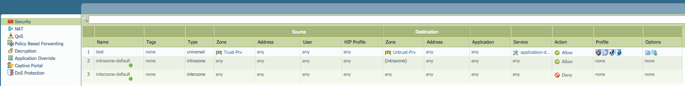
Figure 1: Security Rules in Panorama
The following NAT rules show risks identified for the Panorama.
Table 5: NAT Rule Risks in Panorama
Risks in NAT Rules for Panorama
Line ## | Description of the finding for the rule. | D-3
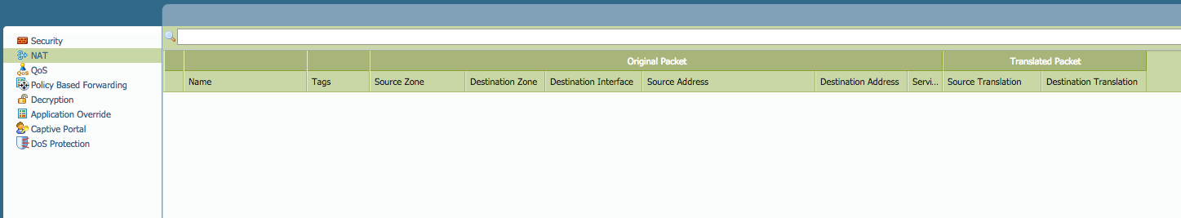
Figure 2: NAT Rules in Panorama

The following QoS rules show risks identified for the Panorama.
Table 6: QoS Rule Risks in Panorama
Risks in QoS Rules for Panorama
Line ## | Description of the finding for the rule. | D-3
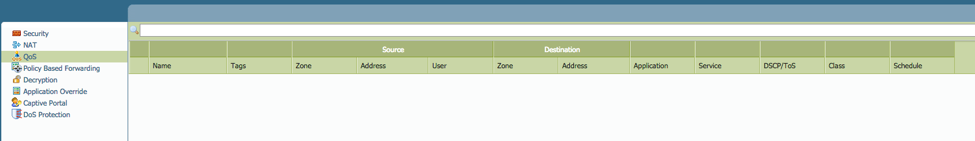
Figure 3: QoS Rules in Panorama

The following PBR rules show risks identified for the Panorama.
Table 7: PBF Rule Risks in Panorama
Risks in PBF Rules for Panorama
Line ## | Description of the finding for the rule. | D-3
Figure 4: PBF Rules in Panorama

The following Decryption rules show risks identified for the Panorama.
Table 8: Decryption Rule Risks in Panorama
Risks in Decryption Rules for Panorama
Line ## | Description of the finding for the rule. | D-3
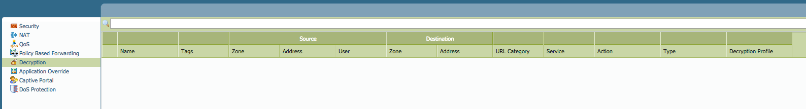
Figure 5: Decryption Rules in Panorama

The following App Override rules show risks identified for the Panorama.
Table 9: App Override Rule Risks in Panorama
Risks in App Override Rules for Panorama
Line ## | Description of the finding for the rule. | D-3
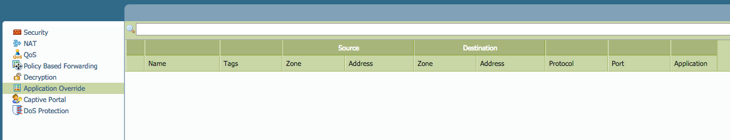
Figure 6: App Override Rules in Panorama

The following Captive Portal rules show risks identified for the Panorama.
Table 10: Captive Portal Rule Risks in Panorama
Risks in Captive Portal Rules for Panorama
Line ## | Description of the finding for the rule. | D-3
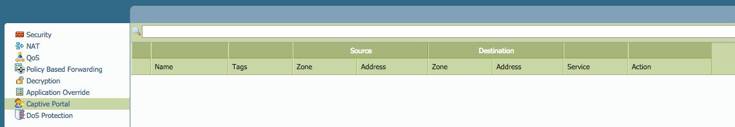
Figure 7: Captive Portal Rules in Panorama
The following DoS rules show risks identified for the Panorama.
Table 11: DoS Rule Risks in Panorama
Risks in DoS Rules for Panorama
Line ## | Description of the finding for the rule. | D-3
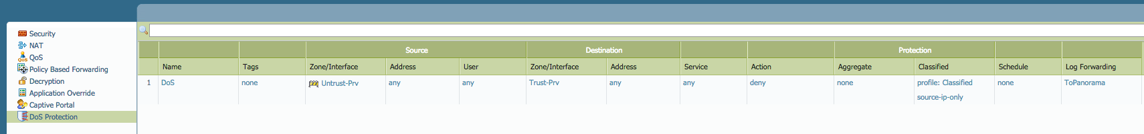
Figure 8: DoS Rules in Panorama

PAN Firewall(s)

Review and Analysis of Firewall(s)
Optiv was able to perform a review of the PAN firewall(s) environment.
Table 12: Firewall Observations
PAN Firewall
Software | Operating Systems – firewalls are running on version x.x. What is recommended? | D-5
Licensing | Are licenses correct and current? | D-5
Administrator Authentication | Are the firewall(s) using local, radius, LDAP, or Kerberos authentication? | D-5
Management Access | What networks can access the individual firewall(s)? | D-3
Log Configurations | Are logs sent to Panorama, email, or syslog? Are they correct? | D-5
Dynamic Updates | Are dynamic updates configured? | D-4
High Availability | Are backup ports being utilized?  Are the firewalls using link or path monitoring? | D-4
Templates | Are templates used? | D-5
Routing | Is static or Dynamic routing being used? | D-5
GlobalProtect | Is GlobalProtect being used? Single or multiple Gateways? Certificates? | D-5
Device Groups | Are Device Groups used? | D-5
Security Policy
DoS | DoS protection rules are being utilized | D-5
Zone Protection | Is zone protection implemented? | D-5
QoS | Are QoS rules being utilized? | D-5
Decryption | Is Decryption being used? | D-5
NAT | Are NATs correct? Are there bi-directional NATs? Is NAT on Panorama or local? | D-5
Security | Deny-All rule at the end is present | D-5
PBF | Is PBF used? | D-5
Captive Portal | Is Captive Portal used? | D-5
Application Override | Is Application Override used? | D-5
DLP | Is DLP configured? | D-3
Threat Prevention | Is threat prevention applied to the rulebase? | D-5
Log Forwarding | The logs are properly forwarded to the Panorama from the firewalls | D-5

The following Security rules show risks identified for the firewall(s).
Table 13: Security Rule Risks in Firewall Y
Risks in Security Rules for Firewall Y
Line ## | Description of finding for rule | D-3
Figure 9: Security Rules in Firewall Y

The following NAT rules show risks identified for the firewall(s).
Table 14: NAT Rule Risks in Firewall Y
Risks in NAT Rules for Firewall Y
Line ## | Description of finding for rule | D-3
Figure 10: NAT Rules in Firewall Y

The following QoS rules show risks identified for the firewall(s).
Table 15: QoS Rule Risks in Firewall Y
Risks in QoS Rules for Firewall Y
Line ## | Description of the finding for the rule. | D-3
Figure 11: QoS Rules in Firewall Y

The following PBR rules show risks identified for the firewall(s).
Table 16: PBF Rule Risks in Firewall Y
Risks in PBF Rules for Firewall Y
Line ## | Description of the finding for the rule. | D-3
Figure 12: PBF Rules in Firewall Y

The following Decryption rules show risks identified for the firewall(s).
Table 17: Decryption Rule Risks in Firewall Y
Risks in Decryption Rules for Firewall Y
Line ## | Description of the finding for the rule. | D-3
Figure 13: Decryption Rules in Firewall Y

The following App Override rules show risks identified for the firewall(s).
Table 18: App Override Rule Risks in Firewall Y
Risks in App Override Rules for Firewall Y
Line ## | Description of the finding for the rule. | D-3
Figure 14: App Override Rules in Firewall Y

The following Captive Portal rules show risks identified for the firewall(s).
Table 19: Captive Portal Rule Risks in Firewall Y
Risks in Captive Portal Rules for Firewall Y
Line ## | Description of the finding for the rule. | D-3
Figure 15: Captive Portal Rules in Firewall Y

The following DoS rules show risks identified for the firewall(s).
Table 20: DoS Rule Risks in Firewall Y
Risks in DoS Rules for Firewall Y
Line ## | Description of the finding for the rule. | D-3
Figure 16: DoS Rules in Firewall Y

Recommendations
This section presents a set of recommendations based on the above findings.
In general, this section focuses on the remediation of D-1, D-2, and D-3 level severity findings; D-4 level findings are addressed but have a lower priority. D-5 findings represent strong points and are therefore not listed below.

High-Level Recommendations
The major problems identified during the review pertain to rules with a source or destination address of any. Also, zones that are marked as any should be restricted by identifying the zones needed. Additionally, outbound access is unrestricted, allowing any application/service to communicate externally.
Similarly, rules with multiple zones do not provide the ability to identify how much traffic each zone generates for other zones based on FireMon reports. The reports are available in Panorama, but are currently limited to a specific time range due to storage capacity constraints. Rules broken down into a single source zone and a single destination zone provide the most visibility and granularity for tighter controls. Also, rules that have any application and any service selected, in most cases, may not need that much access. Identifying applications and services is key to providing only the access that is needed, thereby providing more security.
The reports in the appendices provide some visibility into traffic patterns seen through Panorama for all three firewalls and rule analysis through FireMon for the firewalls. FireMon provides 90-day reports to identify rules that are no longer used and can be optimized. The reports will also be more effective once multiple zone rules are broken apart and re-evaluated after a given period. Currently, reordering rules based on the number of hits cannot be determined because the highest hit rules are the multiple-source zone rules.

High-Level Firewall Recommendations
Table 21: Firewall Recommendations
Area | Recommendation
PAN | High Priority:  - Review rules with ’any any’ defined and restrict access as required.  - Review rules with a source or destination zone set to any and define the required zone(s).  - Review rules with any for source or destination addresses and restrict as required.
PAN | Medium Priority:  - Upgrade the operating system on the firewalls to the latest version of 6.1.x.  - Restrict management access to only allow the IP address or ranges that require management access.  - Separate rules with multiple sourced zones into single zones for greater ability to control and identify traffic rules.  - Review rules with any application/service and restrict access as required.
PAN | Low Priority:  - Review unused rules and remove where practical.  - Configure DLP filtering and apply where needed.  - Configure tags to help group similar policies together when filtered as the rule base grows.

The following Panorama recommendations are listed to show the benefits and risks.
Table 22: Panorama Recommendations
Recommendation | Benefit | Risk
Create Panorama Log Forwarders | PAN endorses the Panorama VM to support only 100 firewalls. Log forwarders will enable Panorama to scale up to 1,500 devices. | - Without log forwarders, the M-100 cannot scale to support the current infrastructure.
Create Panorama Templates | Templates allow for central management of firewall devices and network settings. This eliminates the need for local firewall configuration changes and provides efficient management. | - Managing device and network settings separately on the firewall increases the risk that there will be deviations between firewalls.  - Network settings configured on the firewall cannot be referenced in Panorama configurations (e.g., interface number and IP for NAT or static routes).
The following firewall recommendations are listed to show the benefits and risks.
Table 23: Firewall Recommendations
Recommendation | Benefit | Risk
Policy Cleanup | Removal of obsolete or duplicate rules | - Obsolete rules could permit unwanted traffic  - Obsolete/unused rules add management and performance overhead  - Before removing existing rules, validate that they are unused to mitigate the risk of unwanted downtime  - Certain compliance programs require documentation and justification for policy rules, as well as regular policy review
Policy Conversion to Application-based Rules | Port-based rules are a legacy technology that cannot adequately control traffic to meet the requirements set forth in the blueprint | - Port-based rule can permit unwanted traffic  - Port-based rules can permit malware  - Adequate review and planning are required to ensure that valid traffic is not impacted
- Reports
The following reports give visibility into the applications that are hitting the overly general rules. The PDFs are best viewed through a PDF reader to preserve the formatting.
- Interviews
The following people were interviewed to gain insight into the environment.
- References
The following references are used in the Health Check.
- Devices Included in Review
Table 24: Reviewed Devices
Hostname | Management IP | Type | Hardware | URL Filtering | SSL Decryption
Xxx | Xxx | Xxx | Xxx | Xxx | Xxx

General

Copyright
The information transmitted in this document is intended only for the addressee and may contain confidential and/or privileged material. Any interception, review, retransmission, dissemination, or other use of or taking of any action upon this information by persons or entities other than the intended recipient is prohibited by law and may subject them to criminal or civil liability.
Copyright © 2026 Optiv Security Inc. All rights reserved. The Optiv Security logo is a registered trademark of Optiv Security. All other products and company names mentioned herein are trademarks or registered trademarks of their respective owners.

Version Control
PAN Health Check
Client Name | {{ short_name }}
Client Contact
Document Revision Number | {{ revision_number }}
Author(s)
Peer Reviewer
QA Reviewer
Project Manager
Delivery Date | May 1, 2026
Data Classification | Client Confidential


Optiv is the cyber advisory and solutions leader, delivering strategic and technical expertise to more than 6,000 companies across every major industry. We partner with organizations to advise, deploy and operate complete cybersecurity programs from strategy and managed security services to risk, integration and technology solutions. With clients at the center of our unmatched ecosystem of people, products, partners and programs, we accelerate business progress like no other company can. At Optiv, we manage cyber risk so you can secure your full potential.

©2026 Optiv Security Inc. All Rights Reserved. Optiv is a registered trademark of Optiv Inc.

